 HAPPY HILLS RESORT

Client Owned

Used Park Model for Sale

**Year:** 2019 **Length:** 34’ **Make:** Fairmont Cavco

**Serial #:** CFPU53834K4314046

Details

* This Unit is Located in the 5 Month Section of the Park (May 1st to October 1st)
* 2 Bedroom with loft and sofa bed located in walking distance to the pool & playground
* Master bedroom has a queen-sized bed
* Double/Single Bunk bed
* Large loft overlooking the living area
* Open concept with 11’ ceilings and ceiling fan
* Full 4-piece bathroom
* Stainless steel appliances
* Deck is equipped with a hard awning
* A/C & Heat
* Underbelly has been sprayfoamed
* **Included:** Queen Bed / Pull-Out Sofa / Fridge / Stove /Microwave
* **Excluded:** Personal Items / Deck Furniture / Deck Storage Box / BBQ / Golf Cart / Lawn Mower

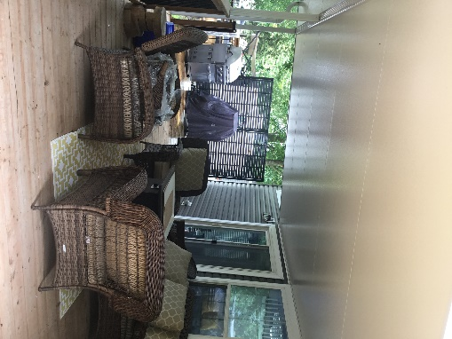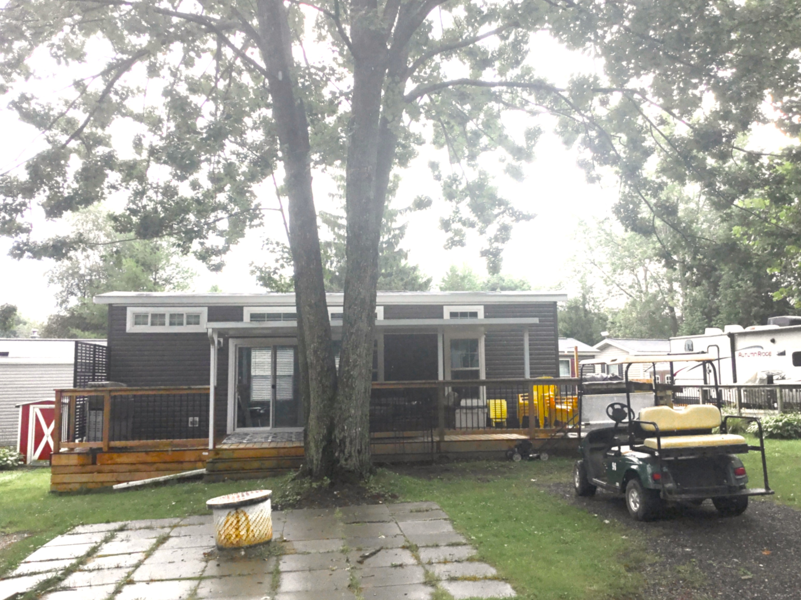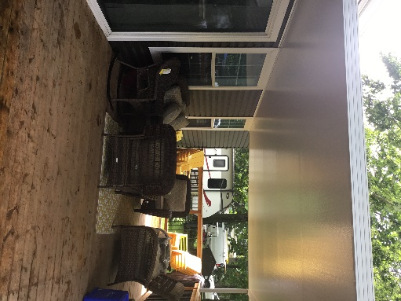

**Price:** $89,999.00 **Location:** 96

**If Interested Please Contact:**

Sylvia: 519-272-9544 Harry: 519-284-3522

e-mail: sylvia.richardson@ed.amdsb.ca

